**COMP 3059 – Capstone Project I**

**Software Requirements Analysis and Design Assignment**

This assignment is an overview to gather the software needs with requirements analysis and help to proceed with the design.

The requirements analysis helps to break down functional and non-functional requirements to a basic design view to provide a clear system development process framework. It involves various entities, including business, stakeholders and technology requirements.

The design is the activity following requirements specification and before programming. Software design usually involves problem solving and planning a software solution.

To work on this assignment you could use the references and a sample template given below. The sample template can be customised to suit the nature of your project.

Reference Readings/Example:

<http://www.uacg.bg/filebank/acadstaff/userfiles/publ_bg_397_SDP_activities_and_steps.pdf>

[www.cse.msu.edu/~chengb/RE-491/Papers/SRSExample-webapp.doc](http://www.cse.msu.edu/~chengb/RE-491/Papers/SRSExample-webapp.doc)

<https://nces.ed.gov/pubs2005/tech_suite/part_2.asp>

Reference template:

[www.tricity.wsu.edu/~mckinnon/cpts322/cpts322-srs-v1.doc](http://www.tricity.wsu.edu/~mckinnon/cpts322/cpts322-srs-v1.doc)

**System Design Document**

**Project Name: ResTaskest**

**Team 30**

Document Version: 1.0

Date: October 31th, 2019

**Table Of Contents**

**1.0 Introduction**

1.1 Purpose

1.2 Scope

**2.0 System Overview**

2.1 Project Perspective

2.2 System Context

2.3 General Constraints

2.4 Assumptions and Dependencies

**3.0 Function Requirements**

3.1 Function Requirement or Features

3.2 Use Cases

*3.2.1 Use Case 1*

*3.2.1 Use Case 2*

*3.2.1 Use Case 3*

3.3 Data Modeling and Analysis

3.4 Process Modeling

**4.0 Non-Functional Requirements**

**5.0 Logical Database Requirements**

**6.0 Other Requirements**

**7.0 Approval**

# 1.0 Introduction

## Purpose

This document describes the high level software requirements for the system. It describes the what, not how, of the capabilities of the system for the intended audiences.

## Scope

This explains what the proposed system will and will not do. Describe relevant benefits, objectives and goals. The description of scope should be consistent with the Project Plan.

# **2.0** **System Overview**

The System Overview section introduces the system context and design.

## 2. 1 Project Perspective

The Project Perspective describes the context and origin of the system by defining whether the system is:

* a follow-on member of a system family
* a replacement for existing systems, or
* a new self-contained system.

## 2.2 System Context

The System Context describes the resulting software within the business case, including strategic issues in which the system is involved or which it specifically addresses.

## 2.3 General Constraints

General Constraints identify any business or system constraints that will impact the manner in which the software is to be:

* specified
* designed
* implemented, or
* tested.

## 2.4 Assumptions and Dependencies

List any assumptions that have been made during the initiation of the project. In addition, list any dependencies that may impact its success or the desired result.

## 3.0 Functional Requirements

This section describes specific features of the software project. If desired, some requirements may be specified in the use-case format and listed in the Use Cases Section.

### 3.1 **Visualize Restaurant Profits**

* Introduction: The profit visualize function is to help restaurant mangers see how their business grows over a period of time
* Inputs: This function takes the operation costs such as the total wages of employees, total spending on material, and
* Processing
* Outputs

...

## 3.2 Use Cases

### 3.2.1 Management Use Cases

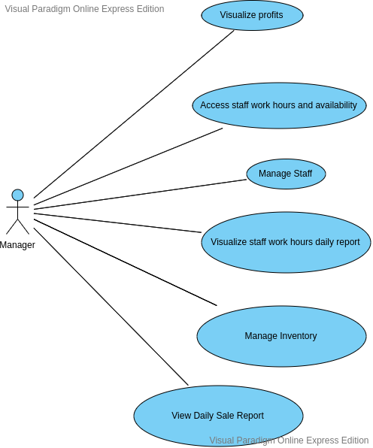

### 3.2.2 **Employees** Use Cases

**3.3 Data Modelling and Analysis**

* Normalized Data Model Diagram
* Activity Diagrams
* Sequence Diagrams
* UML Class Diagram

**3.4 Process Modelling**

* Data Flow Diagram

## 4.0 Non-Functional Requirements

The non-functional requirements for a system are typically constraints on the functional requirements – that is, not what the system does, but how it does it (e.g. how quickly, how efficiently, how easily from the user’s perspective, etc.).

### Non-functional requirements may exist for any of the following attributes – Performance, Reliability, Availability, Security, Maintainability, Portability.

Often these requirements must be achieved at a system-wide level rather than at a unit level. State the requirements in the following sections in measurable terms (e.g., 95% of transaction shall be processed in less than a second, system downtime may not exceed 1 minute per day, etc).

## 5.0 Logical Database Requirements

Will a database be used? If so, what logical requirements exist for data formats, storage capabilities, data retention, data integrity, etc?

## 

## 6.0 Other Requirements

Additional requirements, if any.

**7.0 Approval**

The signatures below indicate their approval of the contents of this document.

|  |  |  |  |
| --- | --- | --- | --- |
| Project Role | Name | Signature | Date |
|  |  |  |  |
|  |  |  |  |
|  |  |  |  |